

BASIC ELECTRONICS

**Table of contents**

1. Voltage / Current / Power 3

2. Resistor 3

3. Capacitor 5

4. Inductor 6

5. Semiconductor 7

6. Diode 7

7. Transistor 8

8. Integrated Circuit (IC) 8

9. Transformer 9

10. Crystal 9

11. Schematic Diagram 10

12. Printed-Circuit-Board (PCB) 10

13. Electronic Module 11

14. Breadboard 11

15. Microcontroller 12

16. Embedded Computer 14

17. GPIO(General-purpose input/output) Pins 16

18. Digital-Analog Pins 17

19. Popular hardware platforms 17

Adafruit Feather 18

Arduino Due 18

Arduino Uno 18

D1 mini 19

Edison Development Board 19

Particle Photon 20

Raspberry Pi 3 20

Raspberry Pi Zero 20

1. Voltage / Current / Power

It all starts with voltage and current. The most common analogy for understanding voltage and current i s water flowing from an elevated tank down through a pipe.

Voltage is represented by water pressure which is determined by the height of the water tank. The higher the tank, the higher the pressure. However, the arbitrary height of the tank isn’t what matters. Instead, what matters is the difference between the tank height and the ground height for the pipes.

The same is true of electrical voltage which is measured in Volts (V). Voltage is measured as a difference between two points. For example, when you say something is 5 volts that really means 5 volts with respect to ground voltage (which is 0 volts).

Electrical current, on the other hand, is equivalent to the amount of water flowing through the pipe, and is measured in Amps (A). It takes voltage to do the work in order to create this current flow. The more voltage that is applied the more current will be produced.

Power is the rate at which work is done and is measured in Watts. There are various equations for calculating electrical power but the easiest one to understand is that power is simply voltage multiplied times current.

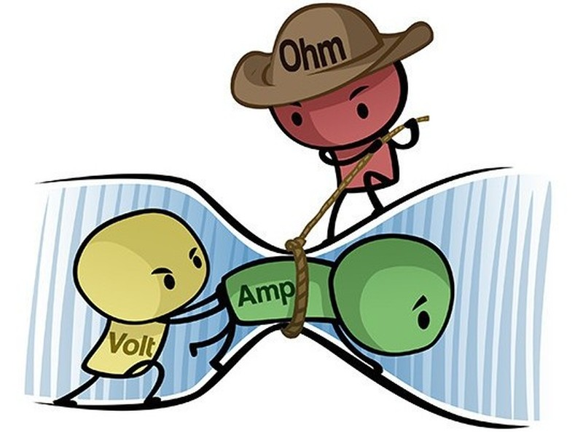

Figure 1: Illustration of voltage, current, and resistance

1. Resistor

As the name implies, a resistor resists the flow of electrical current. The amount of resistance is measured in Ohms. A resistor is considered a passive component that consumes power that is dissipated as heat.

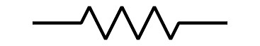

Figure 2: Symbol for a fixed value resistor

The power rating of a resistor determines how much power it can consume without overheating.

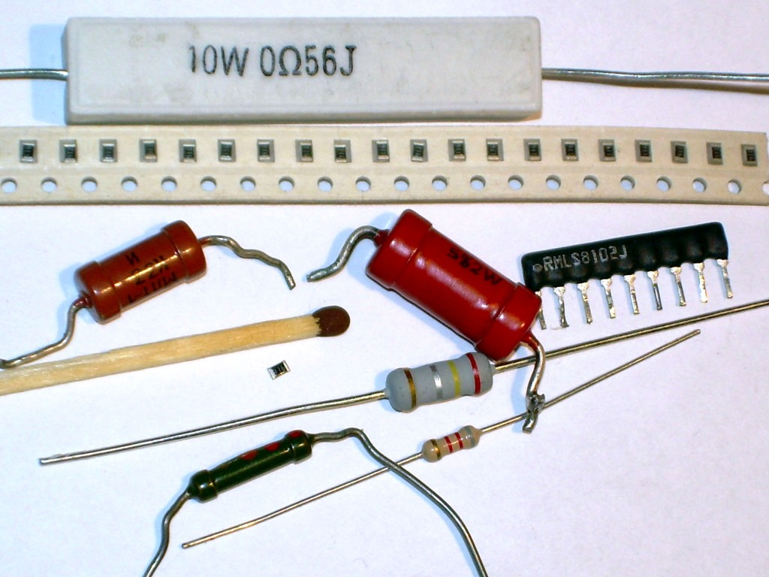

Figure 3: Examples of various styles of fixed resistors

A resistor is undoubtedly the simplest and most commonly used electrical component. Although they fundamentally only resist the flow of current, resistors have a wide variety of uses.

Resistors can be used to accurately divide down a voltage, or limit the amount of current that is allowed to flow. They can also be used for timing purposes and for filtering when coupled with a capacitor or inductor.

The most fundamental, basic equation used in electrical design is Ohm’s Law which defines the relationship between voltage, current, and resistance. This law can be written using the following equation:

Current = Voltage / Resistance

If there is only one electrical equation you should remember it’s Ohm’s Law. As an example of Ohm’s Law, let’s take a look at the simplest circuit possible consisting of a voltage source (V) and a resistor (R).

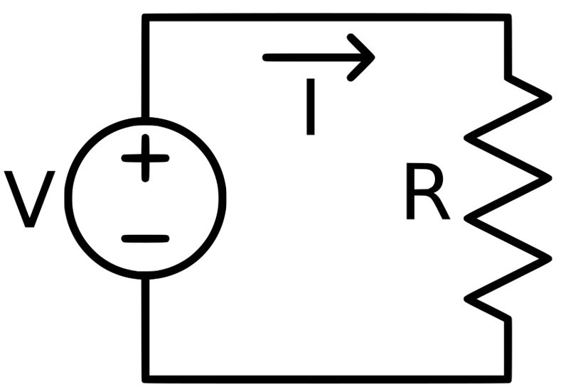

Figure 4 : Simple circuit diagram showing a voltage source and a resistor

Let’s assume the voltage source is 3V and the resistor value is 100 ohms. How much current (I) will flow in this circuit?

Current = Voltage / Resistance = 3 V / 100 ohms = 0.03 A = 30 mA (mA = milliamps = thousandths of an amp)

Most resistances have a fixed, constant value but variable resistors are also available. These variable resistors are called potentiometers.

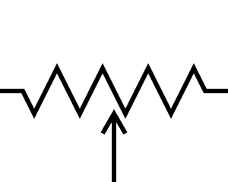

Figure 5 : Symbol for a potentiometers

There are also specialized resistors such as a thermistor whose resistance varies with temperature. A thermistor can be used for measuring temperature.

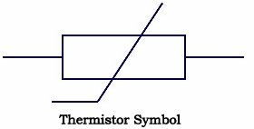

Figure 6 : Symbol for a thermistor

1. Capacitor

A capacitor fundamentally stores electrical energy. In many ways, you can consider a capacitor as a rechargeable battery. Capacitors and resistors are easily the two most commonly used electrical components.

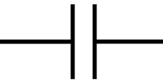

Figure 7 : Symbol for a capacitor

Capacitance is the amount of energy a capacitor can store and is measured in a unit called Farads (F).

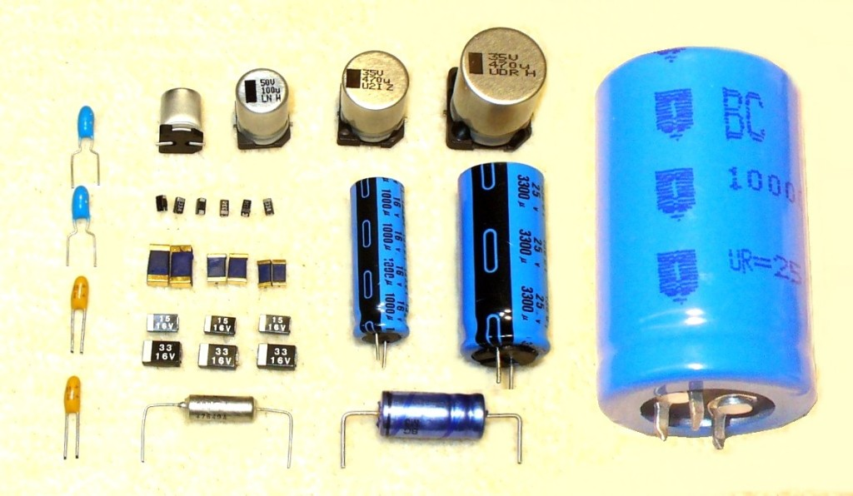

Figure 8 : Examples of various capacitors

Capacitors have many purposes including energy storage, filtering, timing, and decoupling.

One fundamental characteristic of capacitors that make them useful for filtering is their resistance (technically called their impedance) decreases as frequency increases.

1. Inductor

An inductor is simply a coil of wire, and in fact they are commonly called coils. Like a capacitor, an inductor stores electrical energy. However, a capacitor stores this energy electrically, whereas an inductor stores it magnetically.



Figure 9 : Symbol for an inductor

Resistors, capacitors and inductors are the three types of passive electrical components. However, inductors are not nearly as common as resistors and capacitors. The most common use of inductors is in a type of circuit called a switching regulator (see below). Inductors are also commonly used for filtering.

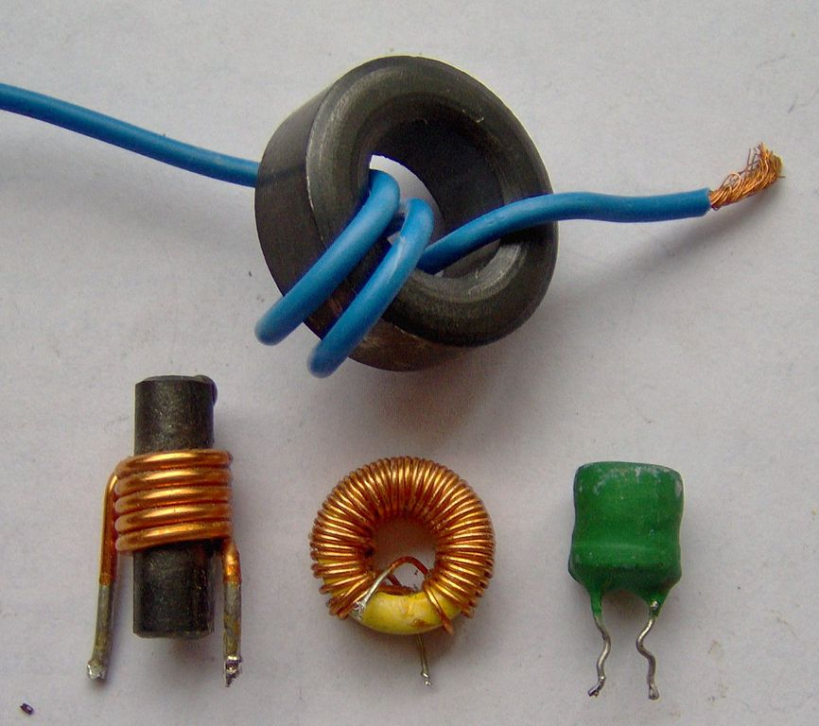

Figure 10 : Examples of various inductors

1. Semiconductor

A semiconductor is a material that is on the threshold between being a conductor and being insulator. The most common semiconductor material by far is silicon. Using semiconductor materials it’s possible to construct electrical devices that can operate as both a conductor and an insulator, just like a switch.

Diodes and transistors are two of the most important components created from semiconductor materials.

1. Diode

A diode is a type of semiconductor device. The most common function of a diode is it allows current to only flow in one direction.

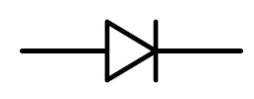

Figure 11 : Symbol for a diode

A special type of diode called a Light-Emitting Diode (LED) is also extremely common. In an LED, as the electrical current passes through the semiconductor diode it emits photons of light. This process is many times more efficient than light produced via an incandescent light source which wastes power as heat.

1. Transistor

Perhaps the most important technological advancement of the past century is the transistor. Transistors are the fundamental component behind any modern computer. A transistor is nothing but an electrical switch.

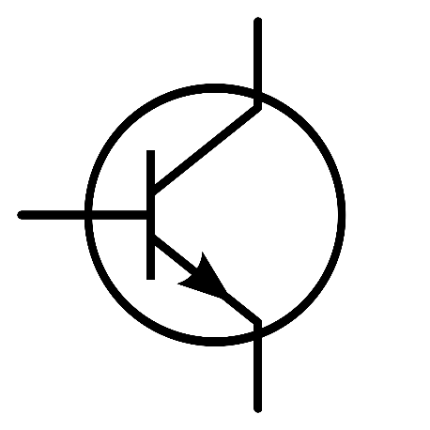

Figure 12 : Symbol for a transistor

Transistors can also be used in analog applications where instead of being either fully on or off, they can be used to control how much current passes through them. For example, a common analog use of transistors is for amplifying a signal.

1. Integrated Circuit (IC)

An integrated circuit is a single piece of semiconductor material (once again, usually silicon) that holds various electrical components (transistors, diodes, resistors, and capacitors).

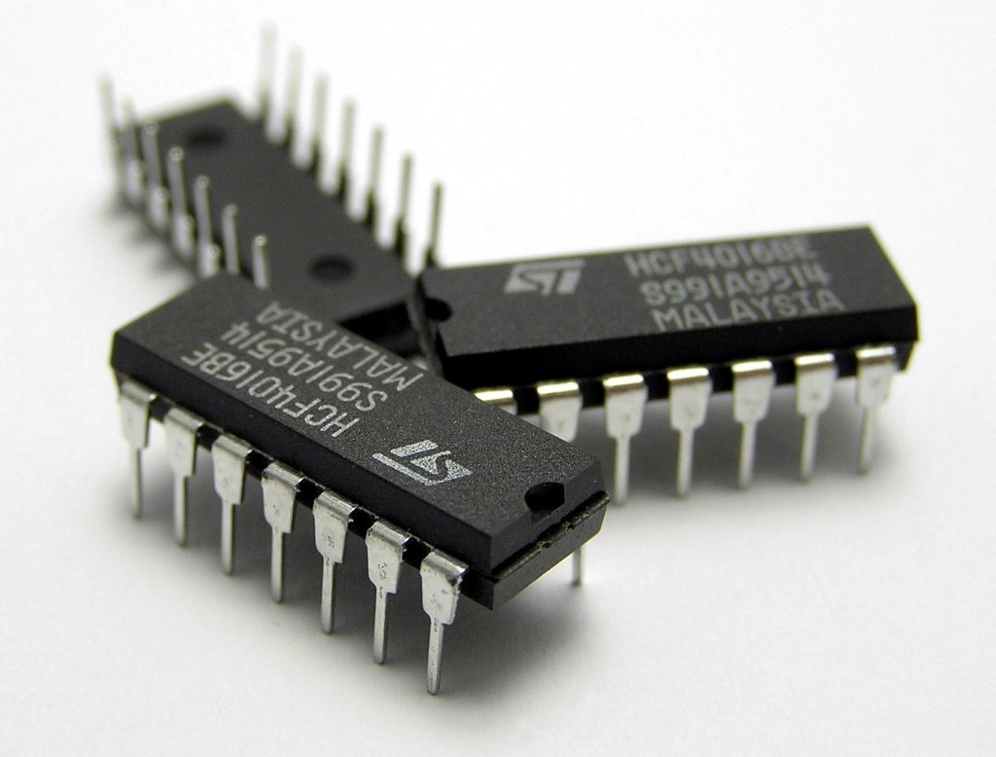

Figure 13 : Examples of Integrated Circuits (ICs)

Instead of a circuit made up of discrete components, an IC incorporates them all together. This allows signals between the components to travel much faster without any power loss.

1. Transformer

A transformer consists of two or more inductor coils. Energy is transferred from one coil to the other via a magnetic field. The most common use of a transformer is to step up or down a voltage. They are most commonly used in AC-to-DC converters.

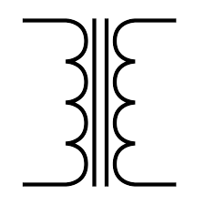

Figure 14 : Symbol for a transformer

1. Crystal

A crystal is a piece of quartz that operates on a physical principle known as the piezoelectric effect. When you squeeze a piece of quartz it electrically oscillates at a very precise frequency dependent on the mechanical pressure applied.

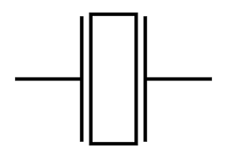

Figure 15 : Symbol for a crystal

1. Schematic Diagram

A schematic is a conceptual engineering diagram that shows how all of the electronic components connect together. The various components are represented using the symbols shown throughout this article.

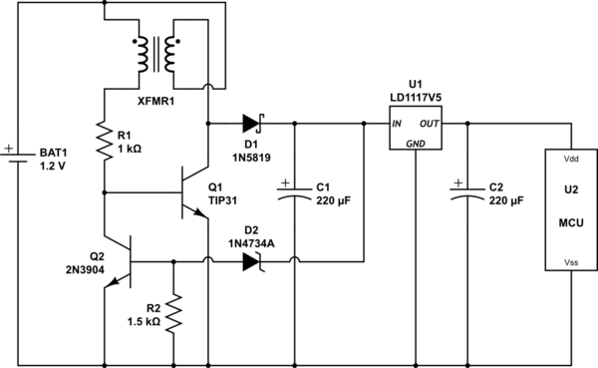

Figure 16 : Example of a schematic circuit diagram

1. Printed-Circuit-Board (PCB)

A schematic is only an abstract diagram. To make it into a real-world design it must now be “converted” into a Printed Circuit Board (PCB) layout.

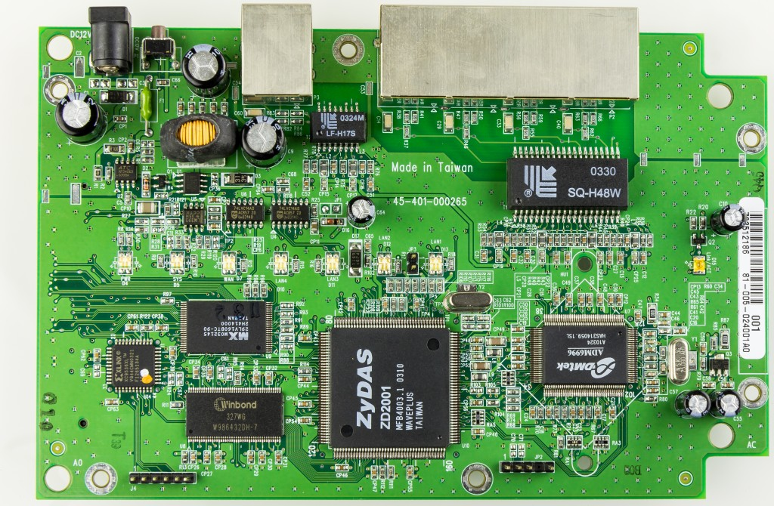

Figure 17 : Example of a Printed Circuit Board (PCB)

1. Electronic Module

An electronic module is a self-contained circuit designed to perform a specific function, and to be integrated into an existing system. One of the most common types of electronic modules is a wireless module.

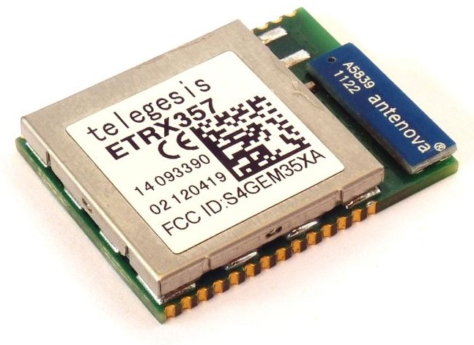

Figure 18 : Example of an electronic module

1. Breadboard

A breadboard is a solderless prototyping board that allows you to quickly and easily connect various electronic components including even some fairly simple microchips.

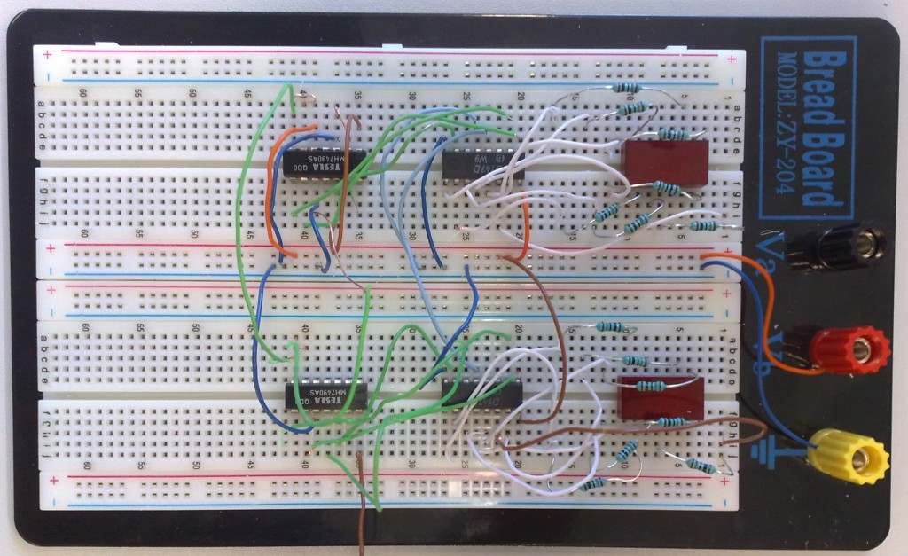

*Figure* 19 *: Example of a circuit constructed using a breadboard*

1. Microcontroller

A microcontroller unit (MCU) is a small, self-contained computer that is housed on a single integrated circuit, or microchip. They differ from your desktop computer in that they are typically dedicated to a single function, and are most often embedded in other devices (e.g. cellphones; household electronics).

*What's the difference between microcontroller (MCU) and microprocessor (MPU)?*

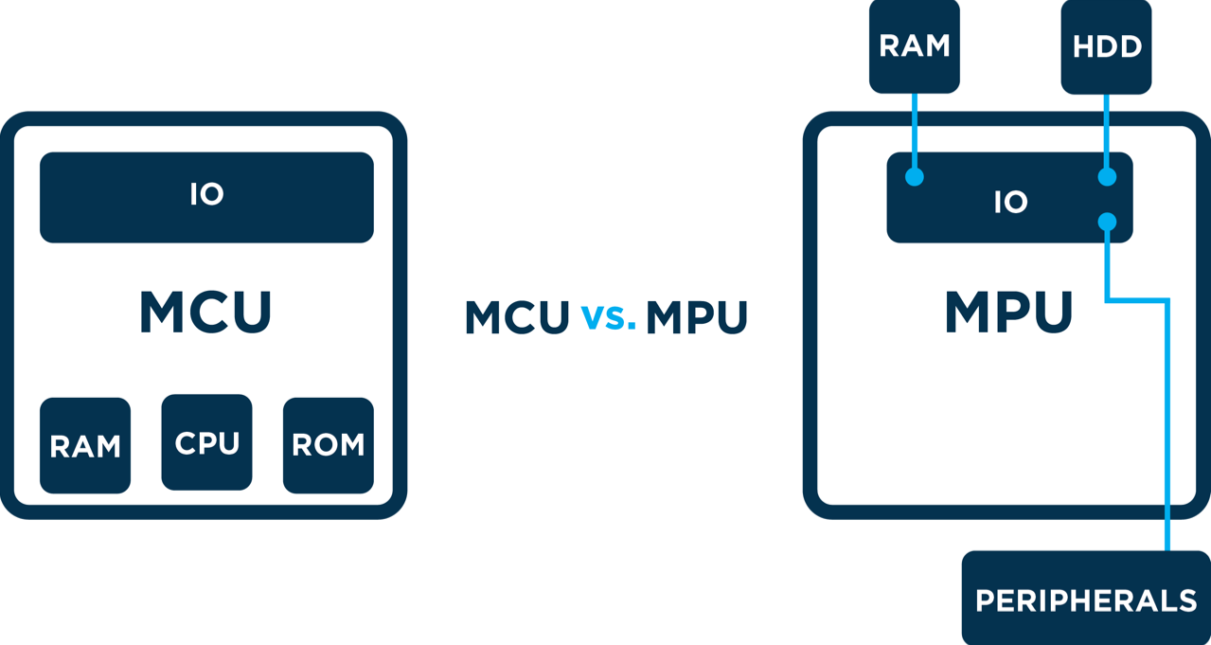

Microcontrollers also differ from microprocessors. Microprocessors contain only a CPU, and therefore require added peripherals to perform tasks. MCUs, on the other hand, contain RAM, ROM, and similar peripherals, which allow them to perform (simple) tasks independently.

Ultimately, despite similar names and appearances, microcontrollers and microprocessors differ widely in their applications. Microprocessors are more powerful, but must be employed as single components in larger systems to function. Microcontrollers, meanwhile, are limited in power and functionality, but can perform simple functions independently. Your Apple TV, for example, requires a microprocessor to handle all the varied and demanding tasks it performs. A connected coffeemaker, on the other hand, only needs to perform simple routines and tasks, and therefore employs a microcontroller.

*What is the difference between a microcontroller (MCU) and a system-on-a-chip (MCU vs SOC)?*

The other term one hears often in this discussion is System on a Chip (SoC). The distinction between an MCU and an SoC is much less clear, and the two terms are often used interchangeably. However, in common usage, the term SoC typically refers to MCUs with a greater number of onboard peripherals and functionality. For the purposes of this outline, we won’t make a distinction between MCUs and SoCs.

*Why use an MCU for IoT?*

SIMPLICITY: In most IoT use-cases, the relative simplicity of an MCU is an advantage rather than a disadvantage. MCUs don’t require operating systems to function, and are easy to interface with external devices such as sensors and motors. Their lack of external dependencies also makes them easy to set up. You can simply turn them on, upload firmware, and they work. Additionally, the coding required to program an MCU is minimal.

SECURITY: By virtue of their relative simplicity, MCUs also offer fewer avenues of attack. As a rule, each open port and available protocol is also a potential vulnerability. Code on MCUs runs “bare metal”, meaning it includes no intermediary operating system to execute instructions. This results in limited potential attack vectors and increased inherent security.

COST: In most contemporary IoT applications, an MCU can deliver all the processing power and functionality one needs. As a result, MCUs are most often the best, most economic hardware choice for IoT applications. Overall, they offer simple, secure, functionality for little cost.

*Which MCU is right for you?*

When selecting an MCU for your IoT project, it is important that you consider three core variables — technical specifications, cost, and support.

TECH SPECS: Which technical specifications your MCU should have will depend entirely upon its intended application. The relative importance of specs such as processing speed and memory capacity will be different from use-case to use-case. For example, An IoT device meant to perform more demanding tasks will necessitate an MCU with a higher clock speed. Less processing-intensive tasks, however, may not necessitate such high-performance hardware. That’s why it is imperative that you clearly determine your technical needs before deciding upon a specific piece of technology. Overall, primary spec considerations include: memory; speed; power use; security features; and connectivity type (Bluetooth/Wi-Fi/Cellular).

COST: All these technical specifications will be invariably weighed against their cost. Although the cost of MCUs is rapidly decreasing, added power, memory, and other specs will generally result in increased costs. While the costs of hardware may not seem daunting initially, increases in scale can quickly amplify even minute differences in hardware price. At the same time, selecting an MCU with only the bare minimum specs required to function may leave you unable to implement updates, new features, and other improvements in the future.

SUPPORT: When selecting an MCU, it’s also important to consider the community surrounding it. MCUs with limited adoption will have fewer resources available to aid you in development. Devices like the Photon, on the other hand, already have large communities of users and developers, which makes it much easier to find information and support when needed. With a community of over 100,000 developers and engineers, the Particle platform has a wealth of resources available, including sample projects, demos, and development tools. Also, by selecting a more widely adopted MCU, you will ensure that integrating your IoT device with existing cloud services will be easy.

1. Embedded Computer

*What is Embedded Computer?*

When you think of a computer you might imagine the monolithic consumer PCs that flooded the market in the 90’s and continue to be produced in huge quantities today. Rectangular black boxes, either laid on their side or stood upright, with a CD or floppy drive on the front, cords protruding from the back and vents cut into the sides to allow airflow to cool the internal components.

As technology has advanced, the size and design of computer systems has changed dramatically. Today’s [commercial embedded computers](https://www.logicsupply.com/products/) barely resemble their desktop tower counterparts. But perhaps even more importantly, the way industry utilizes computers has evolved to include applications that seemed impossible not all that long ago. But what exactly is an “embedded PC” and how does it differ in form and performance from the consumer-grade tower computers that are still prevalent in homes and offices today?

*Embedded Computer vs Industrial PC vs IoT Gateway*

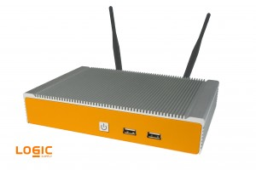Embedded computer systems go by many names (Box PC, [Gateway](https://www.logicsupply.com/products/by-application/iot-gateways-daq-computers/), [Controller](https://www.logicsupply.com/products/by-application/iot-gateways-daq-computers/), [Industrial PC](https://www.logicsupply.com/products/industrial-computers/) etc), but an Embedded PC is essentially any specialized computer system that is implemented as part of a larger device, intelligent system or installation. Embedded computers come in an endless array of shapes and sizes, from the tiny ARM-based devices that power today’s smartphones, to all-in-one solutions that run huge earth movers and military equipment. Embedded computers are also playing a key role in the evolving [Internet of Things](https://www.logicsupply.com/blog/2014/04/11/what-is-the-internet-of-things-and-how-does-logic-supply-fit-in/), enabling the connections between machines, people, places, things and the cloud.

*What’s the Difference Between an Embedded PC and a Tower Computer?*

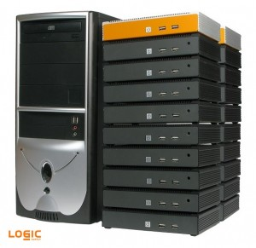

*20 ML300 Systems Next to a traditional computer tower.*

An embedded PC is most easily defined by how it’s used, but there are some key features that have made embedded computers a vital part of modern system design. Embedded computers offer a number of important advantages over standard consumer-grade hardware.

**Small Form Factor:** One of the standout features of nearly all embedded computers is their size. Often built around small form factor motherboards like [Mini-ITX](https://www.logicsupply.com/products/by-form-factor/mini-itx-computers/), [Intel’s NUC](https://www.logicsupply.com/products/by-form-factor/nuc-computers/) and even tiny single board devices like the BeagleBone Black, embedded computers can be installed in places where antiquated towers would never fit. Solid state storage and flexible mounting options also allow embedded PCs to be utilized in virtually any position or orientation.

**Low Maintenance:** In many instances embedded computers, as their name suggests, live deep inside complex systems, making reliability incredibly important. Industrial computers are engineered to provide 24 hour, uninterrupted operation, often employing carefully engineered, fanless and ventless enclosures designed to efficiently dissipate heat while protecting internal components from environmental damage ranging from dust and airborne debris to extreme temperatures, moisture and vibration.

**Efficient Cooling:** Consumer-grade computer systems use fans to help circulate air over components and keep them cool. In an embedded system fans create a point of potential failure and require openings in the enclosure to enable air to enter and escape. While some embedded PCs still utilize fans, advancements in passive cooling allow many industrial PCs to remain sealed against the elements while still effectively dissipating heat without the need for fans. Removing the fan decreases failure rates, eliminates noise and provides more space for integral components.

*So, What’s the Best Embedded Computer?*

Embedded computers are being employed by a huge range of industries all over the world that require high-performance computing power that’s easy to integrate into their existing device or serve as the brains behind a new system. From pipeline monitoring in the oil & gas industry to network security devices designed to monitor and counter intrusion vulnerabilities, embedded computers are constantly in use all around us. Finding the best embedded computer requires a complete understanding of the unique application in which it will be used. With so many variables in play that there’s no one-size-fits-all embedded solution.

1. GPIO(General-purpose input/output) Pins

Stands for "General Purpose Input/Output." GPIO is a type of pin found on an integrated circuit that does not have a specific function. While most pins have a dedicated purpose, such as sending a signal to a certain component, the function of a GPIO pin is customizable and can be controlled by software.

*Use GPIO for?*

Not all chips have GPIO pins, but they are commonly found on multifunction chips, such as those used in power managers and audio/video cards. They are also used by system-on-chip (SOC) circuits, which include a processor, memory, and external interfaces all on a single chip. GPIO pins allow these chips to be configured for different purposes and work with several types of components.

A popular device that makes use of GPIO pins is the Raspberry Pi, a single-board computer designed for hobbyists and educational purposes. It includes a row of GPIO pins along the edge of the board that provide the interface between the Raspberry Pi and other components. These pins act as switches that output 3.3 volts when set to HIGH and no voltage when set to LOW. You can connect a device to specific GPIO pins and control it with a software program. For example, you can wire an LED to a GPIO and a ground pin on a Raspberry Pi. If a software program tells the GPIO pin to turn on, the LED will light up.

1. Digital-Analog Pins

Digital input signals are used to represent items that only have two (2) states, such as... ON (binary 1) or OFF (binary 0) states. Similarly, Digital output signals are used to control items that again only have two states, such as.. START or STOP a device.

So, a digital signal is something like telling if a door is open or not.

Analog signals are variable, they have multiple states. Analog input signals can represent such items as temperature or level or rate of flow. Analog output signals are also variable and can be used for such things as opening a valve to a desired position.

Then, an analog signal is something like telling how much the door is open (or closed).

In our day to day life, we mainly do analog measurements and all analog signals includes the digital ones like a door is 0%=closed or 100%=open. However, digital signals are more suitable for computers (PC/PLC, etc).

An analog signal can only be read by an analog I/O, but a digital one can use both analog or digital I/Os. There is sometime a possibilities to convert an analog signal into a series of digital ones. Because, in practice, you never connect a digital signal to an analog I/O because the analog I/Os are way more expensive than digital ones.

So for a rule of thumb, whenever possible use a digital I/O, since it’s cheap.

In other case, use an analog I/O if the option to convert the signal in a series of digital signals isn’t possible.

For more information about Analog and Digital, please visit:

<https://www.youtube.com/watch?v=WxJKXGugfh8>

1. Popular hardware platforms

|  |  |  |  |  |  |
| --- | --- | --- | --- | --- | --- |
| STT | Name | Price | Spec and Features | Integrations | Details |
| 1 | [Adafruit Feather](https://www.adafruit.com/) | [$29.95](https://www.adafruit.com/products/2829) | |  | | --- | | RAM | | 2K of RAM | | GPIO | | 20 GPIO pins | | Hardware: Size | | 51mm x 23mm x 8mm | | |  | | --- | | Cloud Platforms | | [Microsoft Azure IoT Suite](https://www.postscapes.com/internet-of-things-hardware/#iot-board-comparison/cloud-platform-details4/57d73c5964a7e13b1ad8f00d) | | [Click here](https://www.postscapes.com/internet-of-things-hardware/#iot-board-comparison/view-hardware-details3/57d73d6b1af0df2f1a12c53b?ref=view_218_filters%3D%255B%257B%2522value%2522%253A%2522%2522%252C%2522text%2522%253A%2522All%2520%2522%252C%2522operator%2522%253A%2522is%2520any%2522%252C%2522field%2522%253A%2522field_260%2522%257D%255D%26view_218_page%3D1) |
| 2 | |  | | --- | | [Arduino 101](https://www.arduino.cc/) | | [$30.00](https://store-usa.arduino.cc/products/abx00005?utm_source=redirects&utm_medium=store.arduino.cc&utm_campaign=303_Redirects) | |  | | --- | | RAM 24 kB | | GPIO 20 | | |  | | --- | | Software Support | | [Arduino Software IDE / Wiring](https://www.postscapes.com/internet-of-things-hardware/#iot-board-comparison/software-details3/57d31e5ddaf0a1924951d5ee) [Zephyr Project](https://www.postscapes.com/internet-of-things-hardware/#iot-board-comparison/software-details3/57d321d0787ac3af4a8b8594) | | [Click here](https://www.postscapes.com/internet-of-things-hardware/#iot-board-comparison/view-hardware-details3/57d3288ddaf0a1924951dc39?ref=view_218_filters%3D%255B%257B%2522value%2522%253A%2522%2522%252C%2522text%2522%253A%2522All%2520%2522%252C%2522operator%2522%253A%2522is%2520any%2522%252C%2522field%2522%253A%2522field_260%2522%257D%255D%26view_218_page%3D1) |
| 3 | |  | | --- | | [Arduino Due](https://www.arduino.cc/) | | [$34.99](https://store-usa.arduino.cc/products/abx00004?utm_source=redirects&utm_medium=store.arduino.cc&utm_campaign=303_Redirects) | |  | | --- | | RAM | | Flash Memory 256 KB SRAM 32 KB | | SoC | | [ARM Cortex M0/M0+](https://www.postscapes.com/internet-of-things-hardware/#iot-board-comparison/view-chip-details/57d33a4769f393454f1d7c71) | | Hardware: Size | | 55 mm x 80 mm | | |  | | --- | | Software Support | | [Arduino Software IDE / Wiring](https://www.postscapes.com/internet-of-things-hardware/#iot-board-comparison/software-details3/57d31e5ddaf0a1924951d5ee) [Zephyr Project](https://www.postscapes.com/internet-of-things-hardware/#iot-board-comparison/software-details3/57d321d0787ac3af4a8b8594) | | Cloud Platforms | | [Cloudplugs Platform](https://www.postscapes.com/internet-of-things-hardware/#iot-board-comparison/cloud-platform-details4/57d75600d83f3bce0ae5fe1a) | | [Click here](https://www.postscapes.com/internet-of-things-hardware/#iot-board-comparison/view-hardware-details3/57d32850b9c385274fd27252?ref=view_218_filters%3D%255B%257B%2522value%2522%253A%2522%2522%252C%2522text%2522%253A%2522All%2520%2522%252C%2522operator%2522%253A%2522is%2520any%2522%252C%2522field%2522%253A%2522field_260%2522%257D%255D%26view_218_page%3D1) |
| 4 | |  | | --- | | [Arduino Uno](https://www.arduino.cc/) | | [$24.95](https://store-usa.arduino.cc/products/a000066) | |  | | --- | | RAM | | Flash Memory 32 KB (ATmega328P) of which 0.5 KB used by bootloader SRAM 2 KB (ATmega328P) | | SoC | | [ATmega328P](https://www.postscapes.com/internet-of-things-hardware/#iot-board-comparison/view-chip-details/57dc6ea3026be02d39d7a32f) | | Hardware: Size | | 68.6 mm X 53.4 mm | | |  | | --- | | Software Support | | [Arduino Software IDE / Wiring](https://www.postscapes.com/internet-of-things-hardware/#iot-board-comparison/software-details3/57d31e5ddaf0a1924951d5ee) | | Cloud Platforms | | [Carriots Platform](https://www.postscapes.com/internet-of-things-hardware/#iot-board-comparison/cloud-platform-details4/57d75600d83f3bce0ae5fe14) [Cloudplugs Platform](https://www.postscapes.com/internet-of-things-hardware/#iot-board-comparison/cloud-platform-details4/57d75600d83f3bce0ae5fe1a) | | [click here](https://www.postscapes.com/internet-of-things-hardware/#iot-board-comparison/view-hardware-details3/57d85a27b71635f466d82f7f?ref=view_218_filters%3D%255B%257B%2522value%2522%253A%2522%2522%252C%2522text%2522%253A%2522All%2520%2522%252C%2522operator%2522%253A%2522is%2520any%2522%252C%2522field%2522%253A%2522field_260%2522%257D%255D%26view_218_page%3D1) |
| 5 | |  | | --- | | [D1 mini](http://www.wemos.cc/) | | [$5.00](http://www.aliexpress.com/store/1331105) | |  | | --- | | Memory / Storage | | Flash: 4M bytes | | GPIO 11 | | SoC:[Espressif ESP8266](https://www.postscapes.com/internet-of-things-hardware/#iot-board-comparison/view-chip-details/57e1b83645a3b85b4cfebe21) | | Size34.2mmx25.6mm | |  | | |  | | --- | | Software Support | | [Arduino Software IDE / Wiring](https://www.postscapes.com/internet-of-things-hardware/#iot-board-comparison/software-details3/57d31e5ddaf0a1924951d5ee) [NodeMCU](https://www.postscapes.com/internet-of-things-hardware/#iot-board-comparison/software-details3/57e2d4be2832f2ab5601f773) | | [Click here](https://www.postscapes.com/internet-of-things-hardware/#iot-board-comparison/view-hardware-details3/57d333f7e251d5744ef1a36c?ref=view_218_filters%3D%255B%257B%2522value%2522%253A%2522%2522%252C%2522text%2522%253A%2522All%2520%2522%252C%2522operator%2522%253A%2522is%2520any%2522%252C%2522field%2522%253A%2522field_260%2522%257D%255D%26view_218_page%3D1) |
| 6 | [Edison Development Board](https://software.intel.com/) | $[49.95](http://amzn.to/2ck45wl) | |  | | --- | | RAM: 1GB LPDDR3 POP Memory (2 channel 32bits @ 800MT/sec) | | Memory / Storage | | Flash Storage: 4GB eMMC (v4.51 spec) | | GPIO: 40 | | |  | | --- | | Software Support | | [Arduino Software IDE / Wiring](https://www.postscapes.com/internet-of-things-hardware/#iot-board-comparison/software-details3/57d31e5ddaf0a1924951d5ee) [Brillo](https://www.postscapes.com/internet-of-things-hardware/#iot-board-comparison/software-details3/57e06b698491bef552a76e93) [Intel System Studio for IoT](https://www.postscapes.com/internet-of-things-hardware/#iot-board-comparison/software-details3/57dd73e125f484f440e6e5d7) [Intel XDK](https://www.postscapes.com/internet-of-things-hardware/#iot-board-comparison/software-details3/57dc3d524f65da98387df83b) [Yocto Linux](https://www.postscapes.com/internet-of-things-hardware/#iot-board-comparison/software-details3/57d74020af0a79bd5ede5045) | | Cloud Platforms | | [Cloudplugs Platform](https://www.postscapes.com/internet-of-things-hardware/#iot-board-comparison/cloud-platform-details4/57d75600d83f3bce0ae5fe1a) [Initial State Platform](https://www.postscapes.com/internet-of-things-hardware/#iot-board-comparison/cloud-platform-details4/57d74a3964a7e13b1ad8f269) [Microsoft Azure IoT Suite](https://www.postscapes.com/internet-of-things-hardware/#iot-board-comparison/cloud-platform-details4/57d73c5964a7e13b1ad8f00d) [Thing Plus Platform](https://www.postscapes.com/internet-of-things-hardware/#iot-board-comparison/cloud-platform-details4/57d75603d83f3bce0ae5feb8) [Ubidots Platform](https://www.postscapes.com/internet-of-things-hardware/#iot-board-comparison/cloud-platform-details4/57d75603d83f3bce0ae5fec0) [Wyliodrin Platform](https://www.postscapes.com/internet-of-things-hardware/#iot-board-comparison/cloud-platform-details4/57dd71986b38cd517eab150e) | | Comms | | [Bluetooth/2.1](https://www.postscapes.com/internet-of-things-hardware/#iot-board-comparison/comm-details/57dc5d18a29497a678a25510) [802.11bgn Wifi](https://www.postscapes.com/internet-of-things-hardware/#iot-board-comparison/comm-details/5789cb881e39edc20f3ff130) | | [Click here](https://www.postscapes.com/internet-of-things-hardware/#iot-board-comparison/view-hardware-details3/57d32961c6feac784808da5d?ref=view_218_filters%3D%255B%257B%2522value%2522%253A%2522%2522%252C%2522text%2522%253A%2522All%2520%2522%252C%2522operator%2522%253A%2522is%2520any%2522%252C%2522field%2522%253A%2522field_260%2522%257D%255D%26view_218_page%3D1) |
| 7 | [ESP8266](https://espressif.com/en) | [$6.95](https://www.sparkfun.com/products/13678) | |  | | --- | | Memory / Storage: | | 1MB Flash Memory | | GPIO 16 | | SoC: | | [Espressif ESP8266](https://www.postscapes.com/internet-of-things-hardware/#iot-board-comparison/view-chip-details/57e1b83645a3b85b4cfebe21) | | Size: 25mm x 15mm | | |  | | --- | | Cloud Platforms | | [Blynk Platform](https://www.postscapes.com/internet-of-things-hardware/#iot-board-comparison/cloud-platform-details4/57d7456a64a7e13b1ad8f1e3) [DeviceHive Platform](https://www.postscapes.com/internet-of-things-hardware/#iot-board-comparison/cloud-platform-details4/57d75600d83f3bce0ae5fe22) [Initial State Platform](https://www.postscapes.com/internet-of-things-hardware/#iot-board-comparison/cloud-platform-details4/57d74a3964a7e13b1ad8f269) [Ubidots Platform](https://www.postscapes.com/internet-of-things-hardware/#iot-board-comparison/cloud-platform-details4/57d75603d83f3bce0ae5fec0) | | Comms: [802.11bgn Wifi](https://www.postscapes.com/internet-of-things-hardware/#iot-board-comparison/comm-details/5789cb881e39edc20f3ff130) | | [Click here](https://www.postscapes.com/internet-of-things-hardware/#iot-board-comparison/view-hardware-details3/57d745d054b046c95c982eb4?ref=view_218_filters%3D%255B%257B%2522value%2522%253A%2522%2522%252C%2522text%2522%253A%2522All%2520%2522%252C%2522operator%2522%253A%2522is%2520any%2522%252C%2522field%2522%253A%2522field_260%2522%257D%255D%26view_218_page%3D1) |
| 8 | [Particle Photon](https://www.particle.io/) | [$19.00](https://store.particle.io/#photon) | |  | | --- | | RAM: 128KB RAM | | Memory / Storage: | | 1MB Flash | | GPIO: 18 | | SoC: | | [ARM Cortex M3](https://www.postscapes.com/internet-of-things-hardware/#iot-board-comparison/view-chip-details/57d33a41f9380992505dda97) [STM32F2x5](https://www.postscapes.com/internet-of-things-hardware/#iot-board-comparison/view-chip-details/57e07d2c8491bef552a77414) | | |  | | --- | | Software Support | | [FreeRTOS](https://www.postscapes.com/internet-of-things-hardware/#iot-board-comparison/software-details3/57d741cc1af0df2f1a12c5cf) | | Cloud Platforms | | [Blynk Platform](https://www.postscapes.com/internet-of-things-hardware/#iot-board-comparison/cloud-platform-details4/57d7456a64a7e13b1ad8f1e3) [Particle Cloud](https://www.postscapes.com/internet-of-things-hardware/#iot-board-comparison/cloud-platform-details4/57e07ce210d265674b446d26) [Ubidots Platform](https://www.postscapes.com/internet-of-things-hardware/#iot-board-comparison/cloud-platform-details4/57d75603d83f3bce0ae5fec0) | | Comms | | [802.11bgn Wifi](https://www.postscapes.com/internet-of-things-hardware/#iot-board-comparison/comm-details/5789cb881e39edc20f3ff130) | | [Click here](https://www.postscapes.com/internet-of-things-hardware/#iot-board-comparison/view-hardware-details3/57d3328a555af56a524202a8?ref=view_218_filters%3D%255B%257B%2522value%2522%253A%2522%2522%252C%2522text%2522%253A%2522All%2520%2522%252C%2522operator%2522%253A%2522is%2520any%2522%252C%2522field%2522%253A%2522field_260%2522%257D%255D%26view_218_page%3D2) |
| 9 | |  | | --- | | [Raspberry Pi 3](https://www.raspberrypi.org/) | | [$35.00](https://www.newark.com/raspberry-pi/raspberrypi3-modb-1gb/sbc-raspberry-pi-3-mod-b-1gb-ram/dp/77Y6520?COM=superwidget-link_RaspberryPi%20CMPNULL) | |  | | --- | | Memory / Storage | | 1Gb of Ram  Micro SD | | GPIO 40 | | SoC | | [Broadcom BCM2837](https://www.postscapes.com/internet-of-things-hardware/#iot-board-comparison/view-chip-details/57e087b08491bef552a77542) | | Size | | 85.60 mm × 56.5 mm (3.370 in × 2.224 in) | | |  | | --- | | Software Support | | -[Windows 10 IoT Core](https://www.postscapes.com/internet-of-things-hardware/#iot-board-comparison/software-details3/57d32189fca3e8484cce8495)  -Raspbian  -Android Iot  -Android  -Linux | | Cloud Platforms | | [Microsoft Azure IoT Suite](https://www.postscapes.com/internet-of-things-hardware/#iot-board-comparison/cloud-platform-details4/57d73c5964a7e13b1ad8f00d) [Resin Platform](https://www.postscapes.com/internet-of-things-hardware/#iot-board-comparison/cloud-platform-details4/57d75602d83f3bce0ae5fe90)  ThingSpeaks | | Comms | | [Ethernet](https://www.postscapes.com/internet-of-things-hardware/#iot-board-comparison/comm-details/5789cb8a1e39edc20f3ff139) [802.11bgn Wifi](https://www.postscapes.com/internet-of-things-hardware/#iot-board-comparison/comm-details/5789cb881e39edc20f3ff130) | | [Click here](https://www.postscapes.com/internet-of-things-hardware/#iot-board-comparison/view-hardware-details3/57d3260836d857c74814a382?ref=view_218_filters%3D%255B%257B%2522value%2522%253A%2522%2522%252C%2522text%2522%253A%2522All%2520%2522%252C%2522operator%2522%253A%2522is%2520any%2522%252C%2522field%2522%253A%2522field_260%2522%257D%255D%26view_218_page%3D2) |
| 10 | |  | | --- | | [Raspberry Pi Zero](https://www.raspberrypi.org/) | | [$5.00](https://www.adafruit.com/product/2885) | |  | | --- | | RAM 512MB | | Memory / Storage | | MicroSD card | | SoC | | [Broadcom BCM2835](https://www.postscapes.com/internet-of-things-hardware/#iot-board-comparison/view-chip-details/57e08447ea02521e48e93b4c) | | Size | | 65.0mm x 31.0mm x 5.0mm / 2.6" x 1.2" x 0.2" | | **Software Support**  -Raspbian  -Android Iot  -Android  -Linux   |  | | --- | | Cloud Platforms | | [Resin Platform](https://www.postscapes.com/internet-of-things-hardware/#iot-board-comparison/cloud-platform-details4/57d75602d83f3bce0ae5fe90) | | [Click here](https://www.postscapes.com/internet-of-things-hardware/#iot-board-comparison/view-hardware-details3/57d325f2ce2be6c14cc3a5ae?ref=view_218_filters%3D%255B%257B%2522value%2522%253A%2522%2522%252C%2522text%2522%253A%2522All%2520%2522%252C%2522operator%2522%253A%2522is%2520any%2522%252C%2522field%2522%253A%2522field_260%2522%257D%255D%26view_218_page%3D2) |

***To see all hardware for internet of things, please visit:***

[*https://www.postscapes.com/internet-of-things-hardware/*](https://www.postscapes.com/internet-of-things-hardware/)